# CS 255 System Design Document Template

This template lays out all the different sections that you need to complete for Project Two. Each section has guidance to prompt your thinking. You will need to continually reference the interview transcript as you work to make sure that you are addressing your client’s needs. There is no required length for the final document. Instead the goal is to complete each section based on what your client’s needs are. Remove this note when you are finished, and replace all bracketed text with the relevant information.

## UML Diagrams

### UML Use Case Diagram

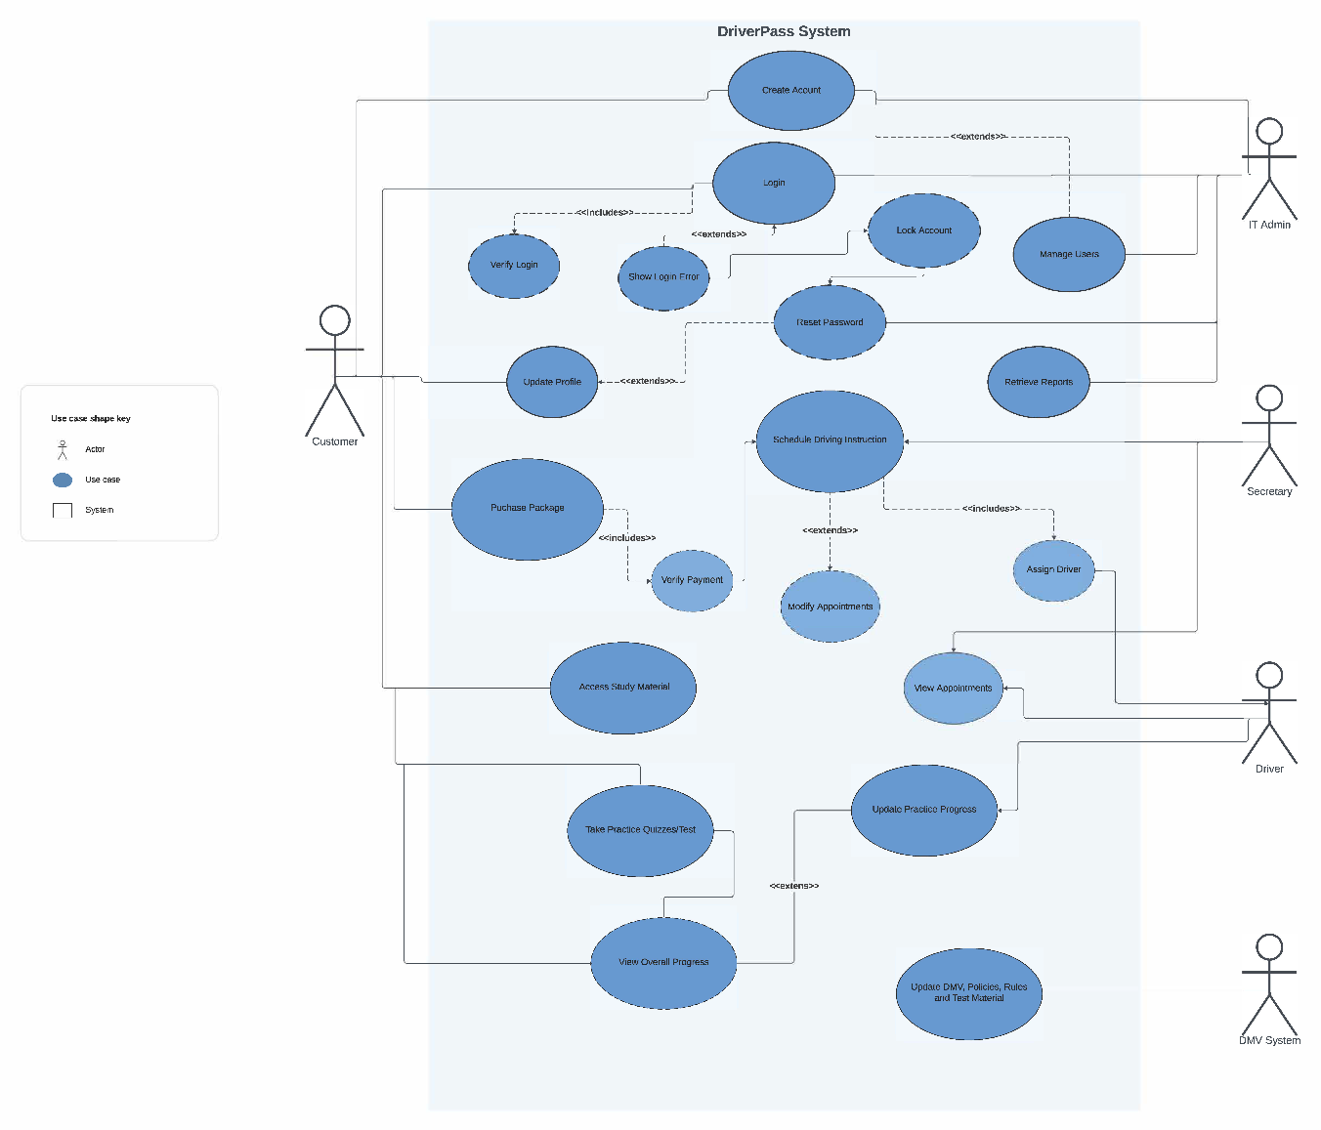

### UML Activity Diagrams

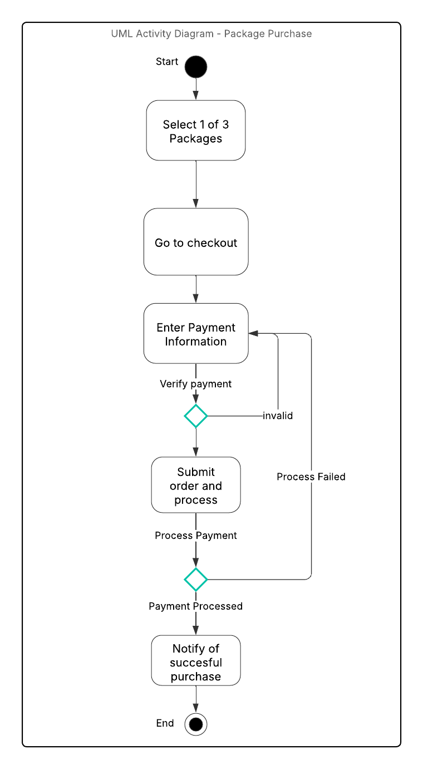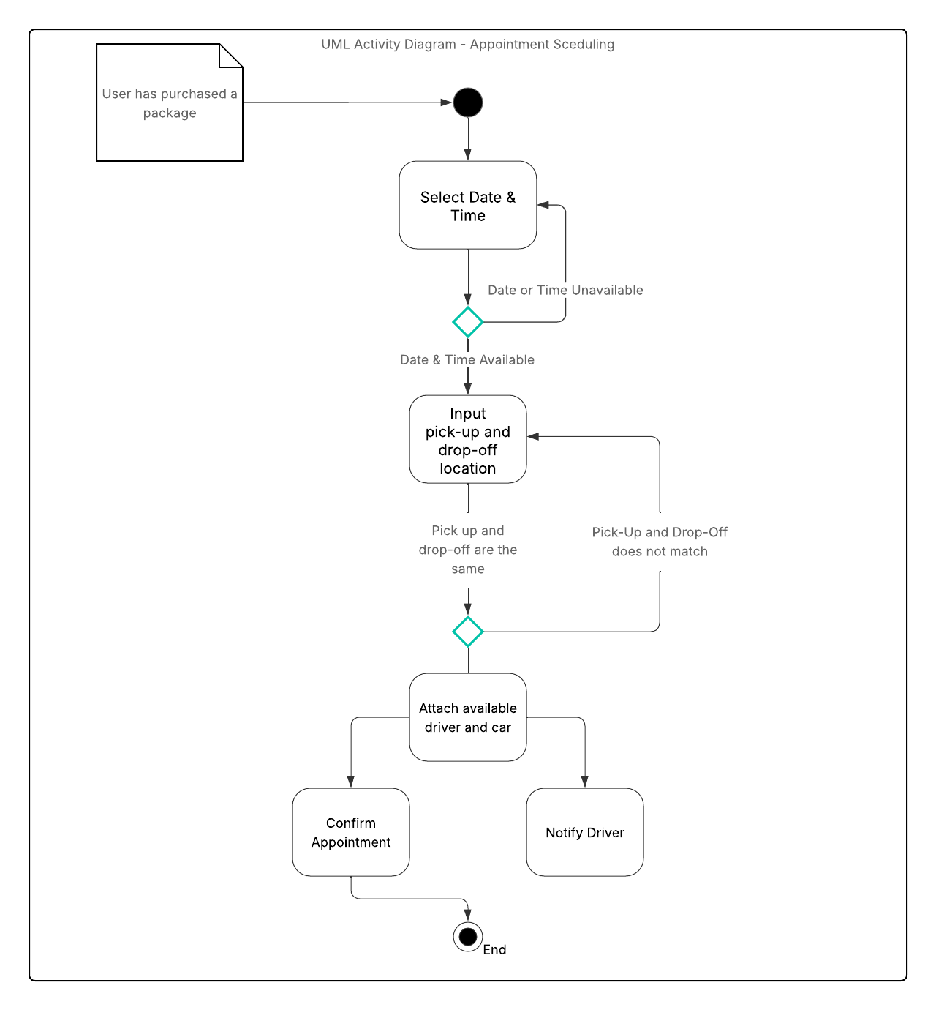

### UML Sequence Diagram

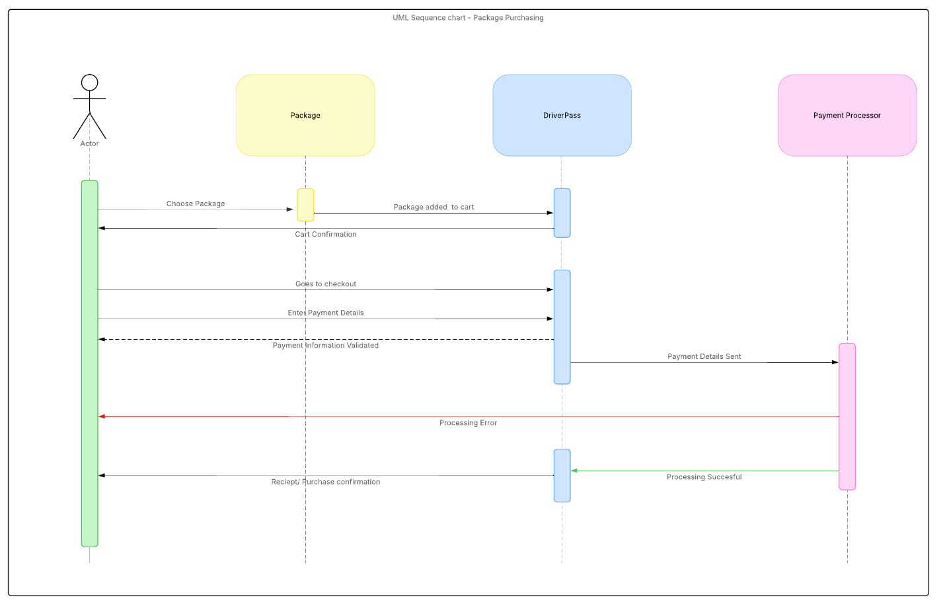

### UML Class Diagram

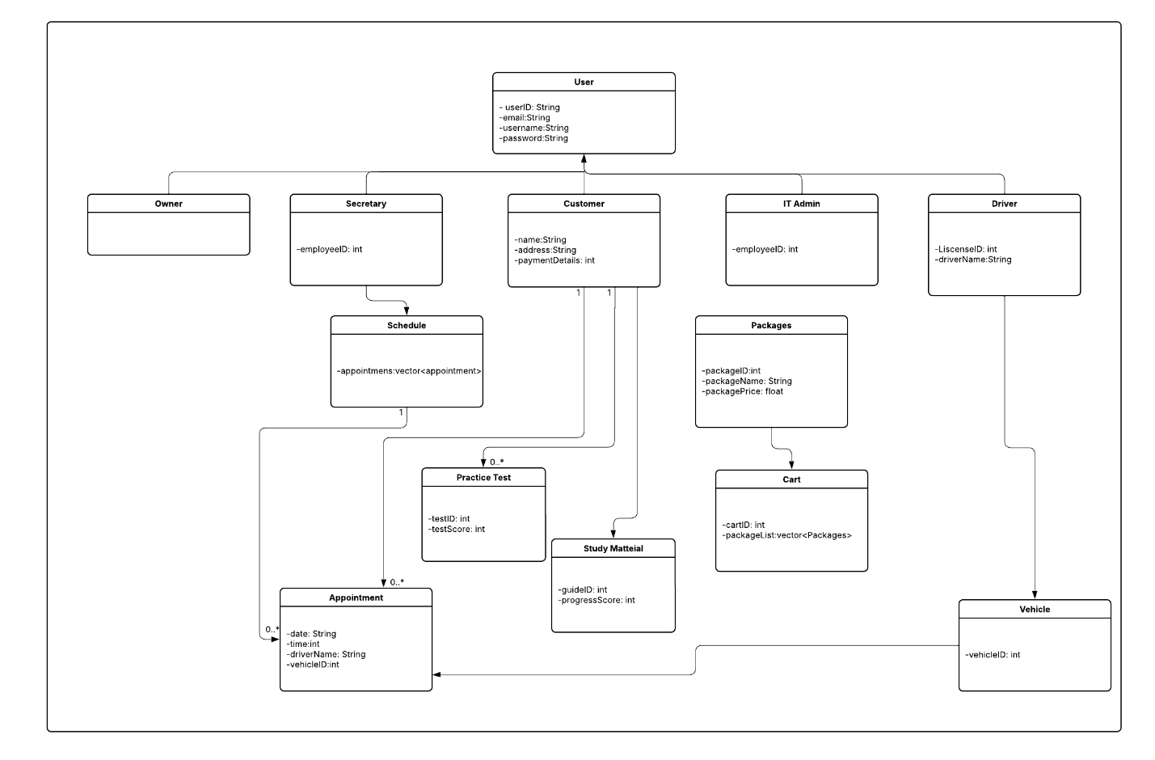

## Technical Requirements

*Hardware:*

*-Servers needed to host the system, including processing power, memory, and storage.*

*-Computers and/or mobile devices will allow users to access the system.*

*-Infrastructure for the network that includes things like routers, switches, firewalls,, etc.*

*Software:*

*-Operating systems like Windows or Linux.*

*-Web browser-related software that will allow access to the website.*

*-Security software: firewalls, antivirus software, etc.*

*Infrastructure:*

*-Data centers to house servers and networking equipment*

*-Cloud services for hosting, storage, and other services*

*-Network connectivity: bandwidth requirements for accessing the system.*